# 1.4 Structure of an HTML document

# 1.5 Basic HTML Tags

## 1.5.1 Headings

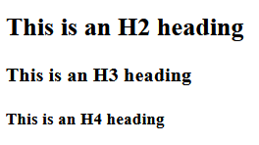

## 1.5.2 Paragraphs and Text Formatting

## 1.5.3 Lists (Ordered and Unordered)

# 1.6 Links and Images

## 1.6.1 Add a Hyperlink



## 1.6.2 Insert An Image

